## “Experiment 1”

## Aim/Overview of the practical:

Familiarization with Arduino/Raspberry Pi hardware and perform necessary software installation.

1. **Apparatus / Simulator Used:**
   * Windows 7 or above
   * Arduino IDE
2. **Objective:**

* To study hardware and software related to IOT.
* To understand the function of Node MCU, Arduino Uno and Raspberry Pi.

## Script and Output:

**About Arduino:**

An Arduino is actually a micro controller-based kit. It is basically used in communications

and in controlling or operating many devices. Arduino UNO board is the most popular board in the Arduino board family. In addition, it is the best board to get started with electronics and coding.

It consists of two memories- Program memory and the data memory.

The code is stored in the flash program memory, whereas the data is stored in the data memory.

Arduino Uno consists of 14 digital input/output pins (of which 6 can be used as PWM outputs), 6 analog inputs, a 16 MHz crystal oscillator, a USB connection, a power jack, an ICSP header, and a reset button.

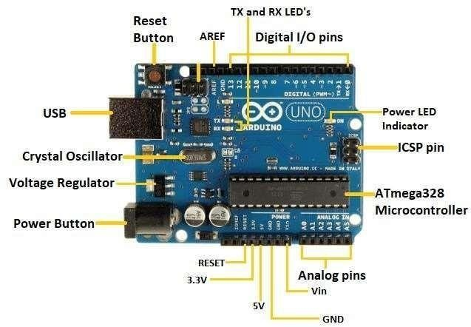

The most important advantage with Arduino is the programs can be directly loaded to the device without requiring any hardware programmer to burn the program. This is done

because of the presence of the 0.5KB of Boot-loader which allows the program to be burned into the circuit. All we have to do is to download the Arduino software and writing the code. The Arduino tool window consists of the toolbar with the buttons like verify, upload, new, open, save, serial monitor. It also consists of a text editor to write the code, a message area which displays the feedback like showing the errors, the text console which displays the output and a series of menus like the File, Edit, Tools menu.

# Steps to install Arduino IDE:

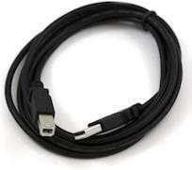***Step 1:-*** First you must have your Arduino board connected using standard USB cable.

***Step 2: -*** Download Arduino IDE Software.

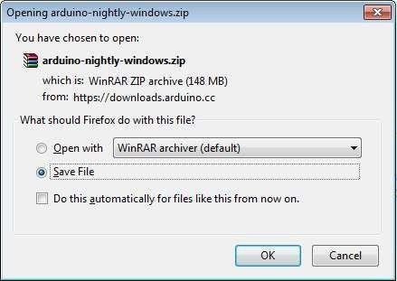

***Step 3: -*** Power up your Arduino board, the powering up takes place automatically by theboard either from the USB connection to the computer or an external power.

***Step 4: -*** Launch Arduino IDE.

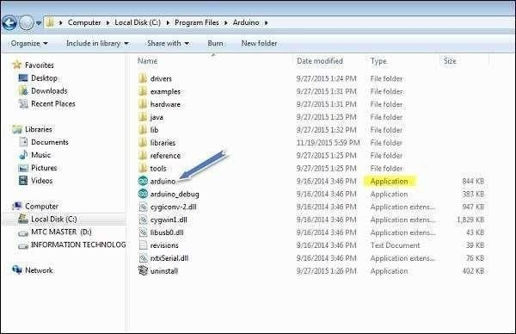

***Step 5:-* Open your first project.**

Once the software starts, you have two options −

* Create a new project.
* Open an existing project example. To create a new project, select File → ***New****.*

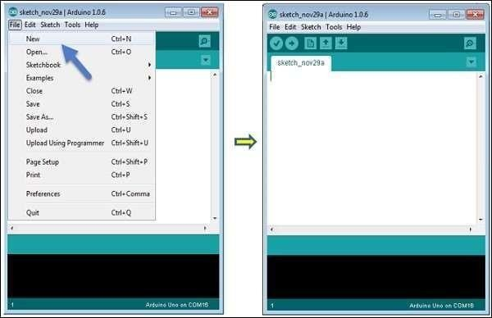

To open an existing project example, select File → Example → Basics → Blink

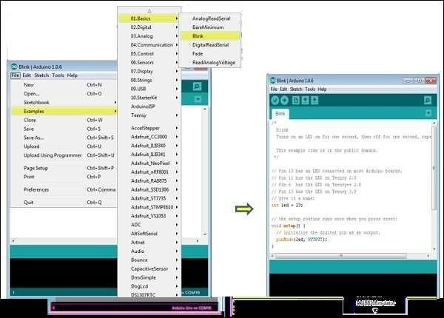

***Step 6:-*** Select your Arduino Board.

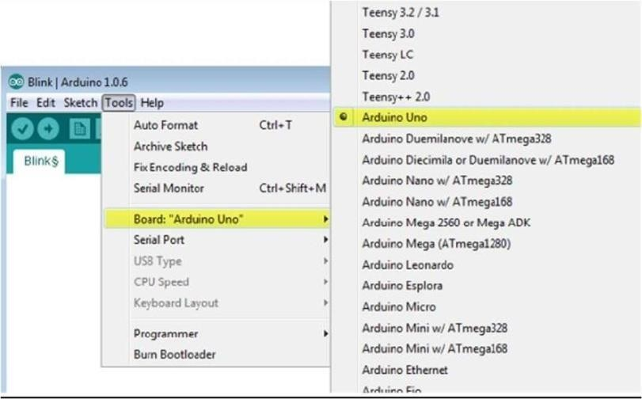

***Step 7:-*** Select your serial port.

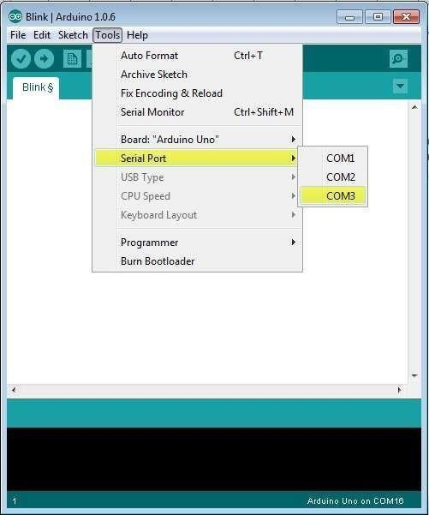

***Step 8:-*** Upload the program to your board.

***Before explaining how we can upload our program to the board, we must demonstratethe function of each symbol appearing in the Arduino IDE toolbar.***

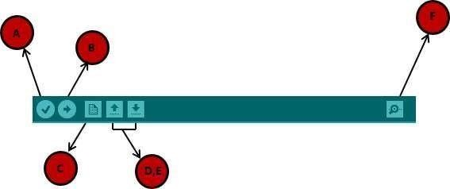

**A** − Used to check if there is any compilation error.

**B** − Used to upload a program to the Arduino board.

**C** − Shortcut used to create a new sketch.

**D** − Used to directly open one of the example sketch.

**E** − Used to save your sketch.

**F** − Serial monitor used to receive serial data from the board and send the serial data to the board.

# About Raspberry Pi:

The Raspberry Pi is a very cheap computer that runs Linux, but it also provides a set of GPIO (general purpose input/output) pins that allow you to control electronic components for physical computing and explore the Internet of Things(IoT). Raspberry Pi was basically introduced in 2006. It is particularly designed for educational use and intended for Python. A Raspberry Pi is of small size i.e., of a credit card sized single board computer, which is developed in the United Kingdom(U.K) by a foundation called Raspberry Pi. There have been three generations of Raspberry Pis: Pi 1, Pi 2, and Pi 3. The first generation of Raspberry(Pi 1) was released in the year 2012, that has two types of models namely model A and model B. Raspberry Pi can be plugged into a TV, computer monitor, and it uses a standard keyboard and mouse. It is user friendly as can be handled by all the age groups. It does everything you would expect a desktop computer to do like word- processing, browsing the internet spreadsheets, playing games to playing high definition videos.

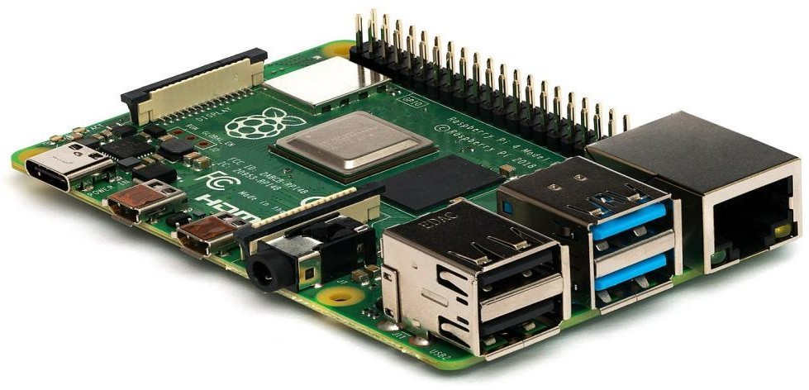

# Downloading and installing Raspberry Pi OS:

Once you have all the components you need, use the following steps to create the boot disk you will need to set up your Raspberry Pi. These steps should work on a using a Windows, Mac or Linux-based PC (we tried this on Windows, but it should be the same on all three).

1. Insert a microSD card / reader into your computer.

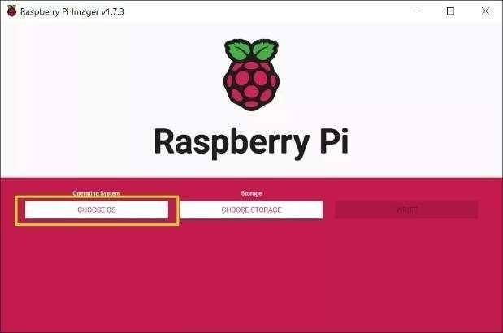

1. Download and install the official Raspberry Pi Imager. Available for Windows, macOS or Linux, this app will both download and install the latest Raspberry Pi OS.There are other ways to do this, namely by downloading a Raspberry Pi OS imagefile and then using a third-party app to “burn it,” but the Imager makes it easier.
2. Click choose OS.
3. Select Raspberry Pi OS (32-bit) from the OS menu (there are other choices, but for most uses, 32-bit is the best).
4. Click Choose storage and pick the SD card you’re using.

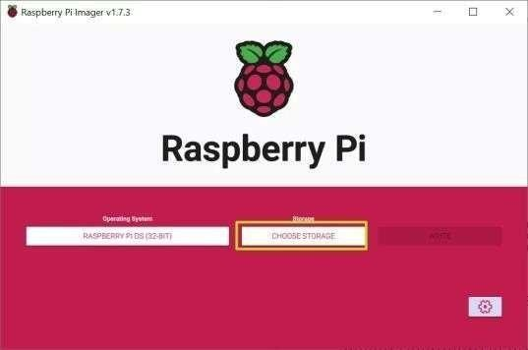

1. Click the settings button or hit CTRL + SHIFT + X to enter settings.
2. Fill in settings fields as follows and then hit Save. All of these fields are technically op- tional,but highly recommended so that can get your Raspberry Pi set up and online as soon as you bootit. If you don't set a username and password here, you'll have to go through a setup wizard that asks you to create them on first boot.

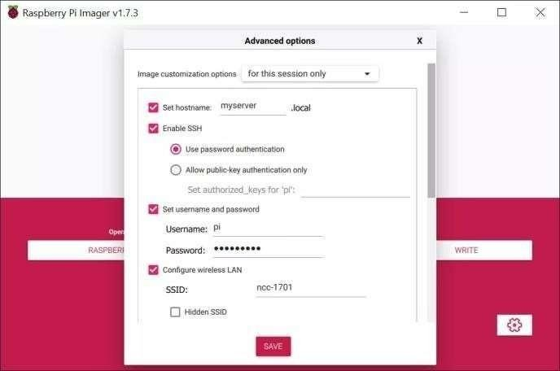

* + **Set host-name**: the name of your Pi. It could be "raspberrypi" or anythingyou like.
  + **Enable SSH**: Allow SSH connections to the Pi. Recommended.
  + **Use password authentication / public key:** method of logging in via SSH
  + **Set username and password:** Pick the username and password you'll usefor the Pi
  + **Configure wireless LAN: s**et the SSID and password of Wi-FI network
  + **Wireless LAN country:** If you're setting up Wi-Fi, you must choose this.
  + **Set locale settings:** Configure keyboard layout and timezone (probably chosen correctly by default)

1. Click Write. The app will now take a few minutes to download the OS and write to yourcard.

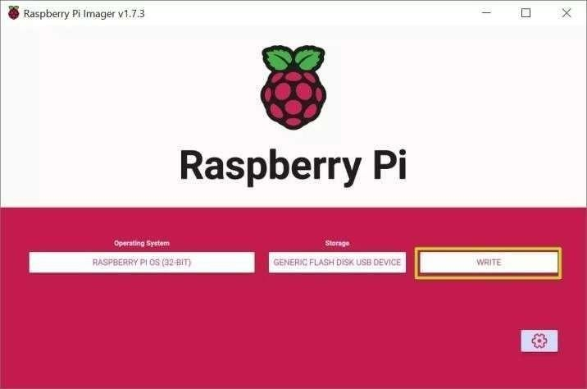

# Booting Raspberry Pi for the first time:

After you're done writing the Raspberry Pi OS to a microSD card, it's time for themoment of truth.

* Insert the microSD card into the Raspberry Pi.
* Connect the Raspberry Pi to a monitor, keyboard and mouse.
* Connect an Ethernet cable if you plan to use wired Internet.
* Plug the Pi in to power it on.

**Learning outcomes (What I have learnt):**

* Learned the concept of IOT.
* Learnt about the devices such as Arduino and Raspberry Pi.